Pseud code

SET Total Customers = 12467

SET One or More = Total Customers \* 0.14

SET Citrus Drinks = One or More \* 0.64

DISPLAY One or More

DISPLAY Citrus Drinks

Screenshots

Compile Screenshot

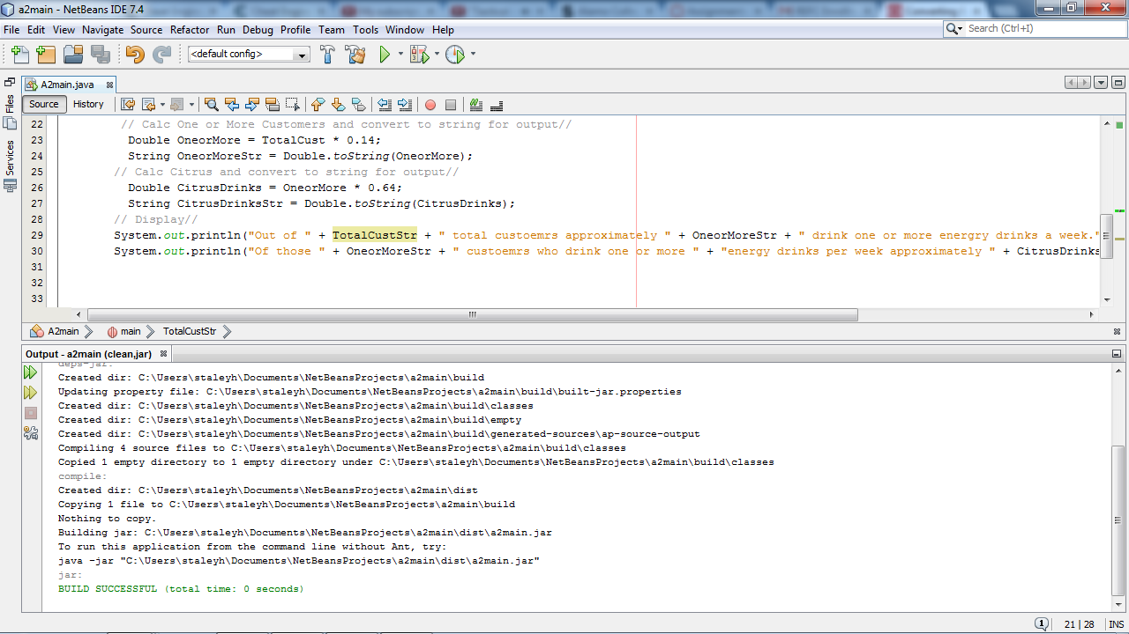

Run Screenshot